SETUP ENVIRONMENT :

FLASK CREATION

|  |  |
| --- | --- |
| TEAM ID | PNT2022TMID53527 |
| TEAM LEAD | V.M.SUNILSUDHARSHAN |
| TEAM MEMBER 01 | V.RAMESH ARAVIND |
| TEAM MEMBER 02 | SOMASUNDHARAM |
| TEAM MEMBER 03 | S.YOGESH |

**Flask install**

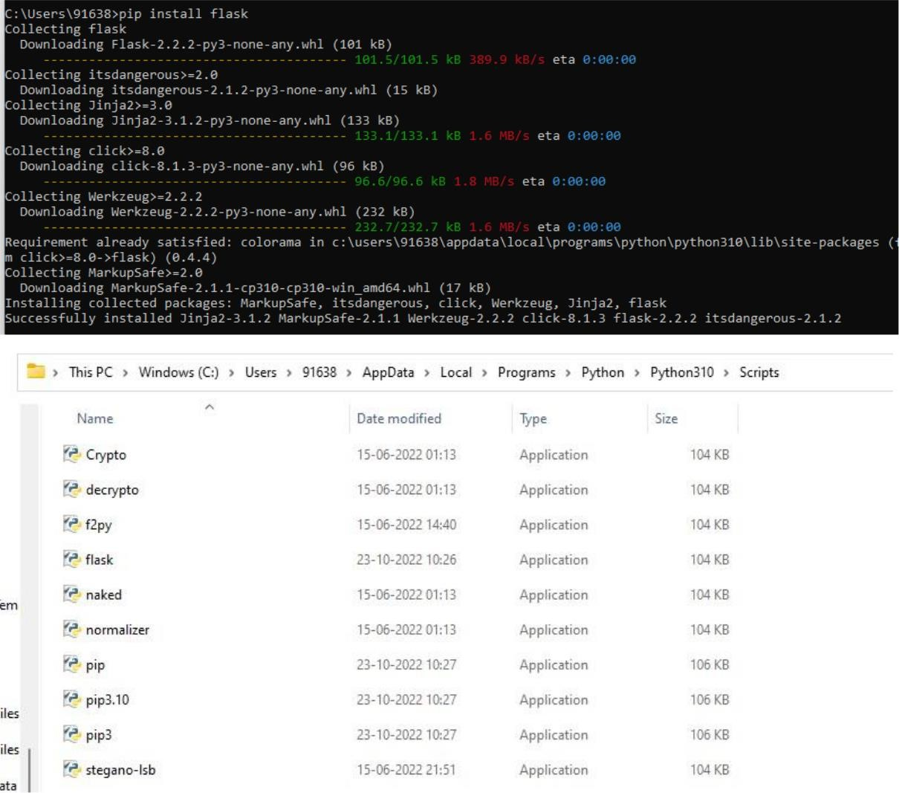

**Create flask:**

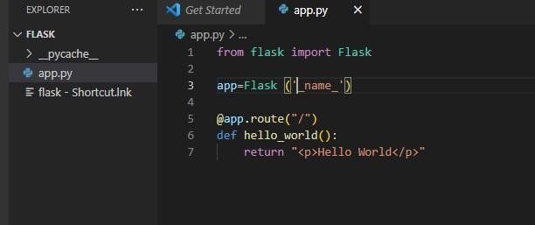



**Run flak:**

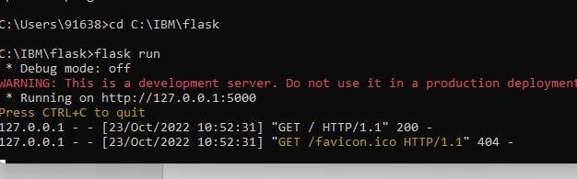

**Output**